January 8th, 2012
Hi
There is a 'primary' election today in HK when people choose which one of the two candidates from the pro-democratic camp they want to stand for the next CE election (in March, I think). I didn't realise until I heard on the radio news a short while ago that all HK permanent residents can vote in this election (in booths at MTR stations). I will not go and vote. Whoever wins does not stand any chance of becoming CE. Only the one backed by China will win, though of course this is not announced publicly.
In the new government headquarters at Tamar, the bacteria that cause legionnaires disease have been discovered in many places, including the wash-room in the CE's office. Several weeks ago, one senior government official - since recovered - was hospitalised with what turned out to be this disease. So the whole building has had to be sanitised. All this is a new building, when the disease is usually found in the water supplies of old buildings. A note about 'bacteria'. On every news report, this word had been used incorrectly, as people don't seen to be able to know that 'bacteria' is plural while the singular is 'bacterium'. So the reports say “The bacteria that causes …......” instead of “The bacterium that causes …......” or “The bacteria that cause …......”.
Nine overseas doctors have been accepted to work in local hospitals, in spite of opposition from many doctors who feel they will not be as good or as well-qualified as local doctors!! This is to overcome a shortage in public hospitals as many doctors move to private hospitals, which are more lucrative. Still nine is not many. Originally more than 200 had applied.
The run yesterday was the same route as last year, in the Cloudy Hill area behind Hong Lok Yuen (where Gavin … - No! I won't make the comment that I have made in past years). Good conditions – cold and dry and especially no wind. At 2 h 46 min, it was the same as last year. This is the run where a few years ago I had the one and only incident of exercise-induced haematuria.
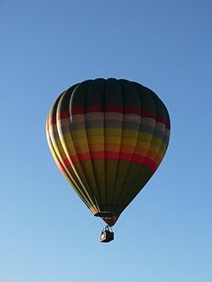
Did you hear of the air tragedy in NZ yesterday? It was on both the local TV news as well as Aus TV. A hot-air balloon caught fire on an early morning flight NE of Wellington, killing all 11 on board. Apparently it hit power lines and caught fire before crashing. (The picture shows the actual hot-air balloon taken on an earlier occasion.) This was the worst NZ air disaster since 1979 when an Air NZ DC-10 crashed into a cloud-covered Mt Erebus in the Antarctic during a sightseeing flight. All 237 passengers and 20 crew members were killed, 22 of them from the US. Both Air NZ and Qantas had such flights but this disaster put an end to that. Sir Edmund Hillary was scheduled to act as the guide for the flight but had to cancel owing to other commitments. The reason for the crash was that Air NZ had changed the previous navigation coordinates that pilots enter into their on-board computers without telling the pilots of the change. The pilots therefore believed they were well away from the mountain when unfortunately the new coordinates took them directly into it. However, I also seem to remember that the pilots had broken a rule which was that they were not to fly through cloud while over the Antarctic. (Pics below show the actual plane and remains on the slopes on the mountain.)
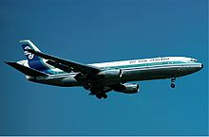
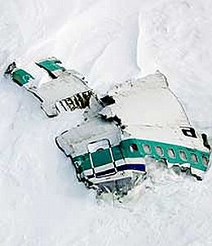
------>

Incidentally, the first air flight Leonie ever had was on an Air NZ DC-10 when in 1980 we flew from HK to NZ and then from NZ to Honolulu. Not long after this, Air NZ got rid of its DC-10s and replaced them with B-747s though this had been planned before the crash.
That’s about it for now.
Cheers

